**CTF Topic: IP Geolocation and Information Gathering with IP API**



**Introduction**

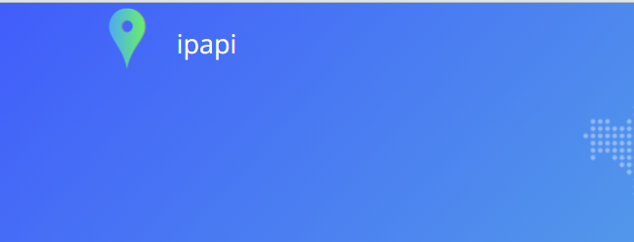

IP API is a powerful tool for IP address lookup and geolocation services. It provides detailed information about an IP address, including its geographical location, ISP, and other metadata. In this challenge, you will use IP API to gather information about the IP address "202.63.241.174".

**Tools and Requirements**

To perform this CTF, you will need the following tools and resources:

* A web browser (e.g., Chrome)
* IP API website: ipapi.co: <https://ipapi.co/>
* The target IP address: 202.63.241.174

**Scenario**

A network analyst, Jamie, has been tasked with gathering detailed information about the IP address 202.63.241.174. Using the IP API tool, Jamie aims to uncover the geographical location, ISP, and other relevant metadata associated with the IP address. This information will help in understanding the origin and potential activities related to the IP address.

**Process to Perform**

**Step 1: Visit IP API Website**

* Open <https://ipapi.co/> in your browser.

**Step 2: Perform IP Lookup**

* Enter the target IP address "202.63.241.174" into the search bar on ipapi.co.
* Click on the lookup button to retrieve information about the IP address.

**Step 3: Analyze the Results**

* Review the detailed information provided by IP APIabout the IP address, such as country, region, city, ISP, and coordinates.
* Note down any significant details or interesting findings.

**Let's Begin the Challenge**

Let's dive into the challenge with the tools and techniques outlined above. Use IP API to uncover detailed information about the target IP address. Document each step you take and any findings along the way.

**Questions**

1. What is the country associated with the IP address 202.63.241.174?

Answer: Nepal

2. What is the city associated with the IP address 202.63.241.174?

Answer: Kathmandu

3. What is the ISP name for the IP address 202.63.241.174?

Answer: Subisu

4. What is the location's Latitude and Longitude for the IP address 202.63.241.174?

Answer: 27.70169, 85.3206

**Happy hunting!**

